**Running MG-RAST**

MG-RAST has a GUI web application for running the software.

First step: make an account. It might take a few days to hear back from the MG-RAST team before your account is activated.



This is what the home screen looks like. To get started, click the upload button.

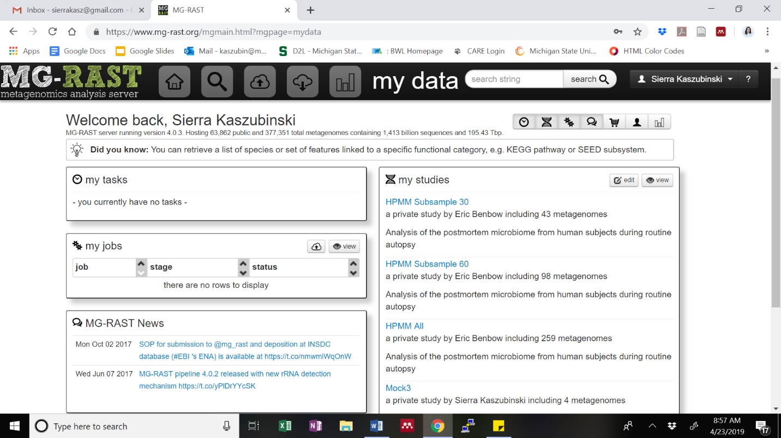

This what the inbox looks like. You can add metadata using the MetaZen tool, or download the Excel template and fill it in, and upload that file. You click upload to add FASTA or FASTQ files.

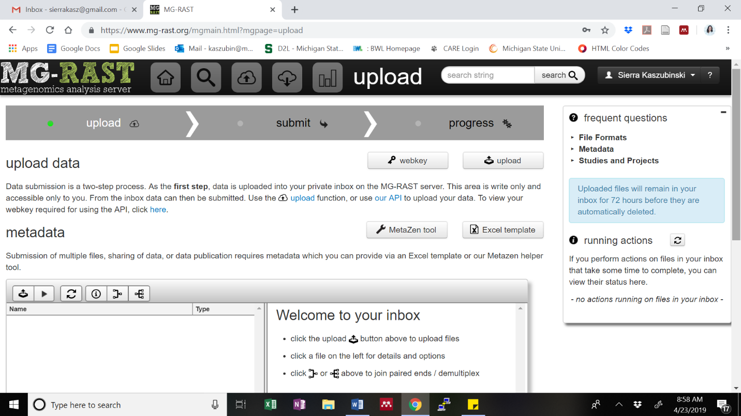

After the files are uploaded, they will be processed. The status of each file is in the running actions box. Green dots means the file is good to go.

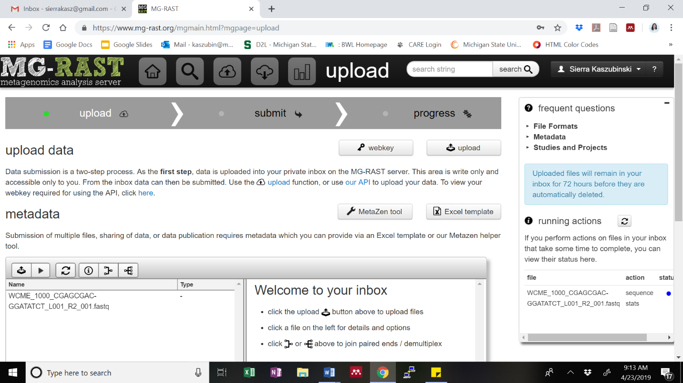

When the processing for all the files is completed, click next for submission.

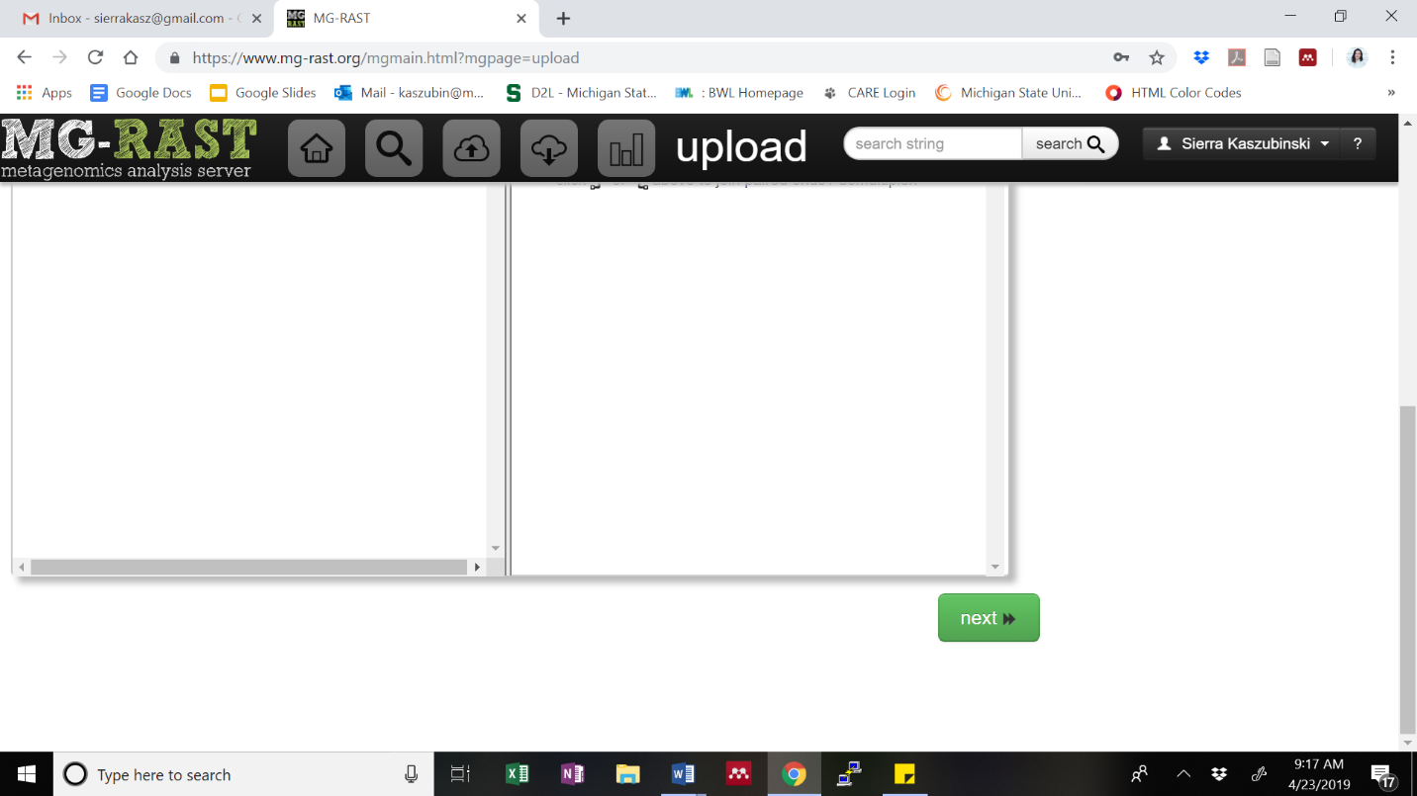

To complete the submission, first select the metadata file uploaded in the inbox.

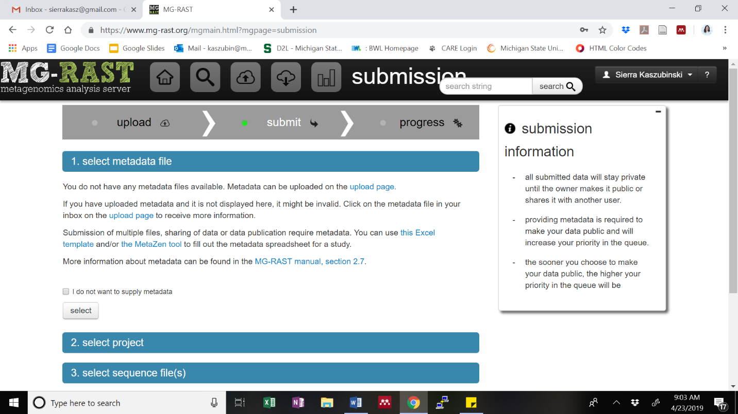

Select a project, which must be named in the metadata file.

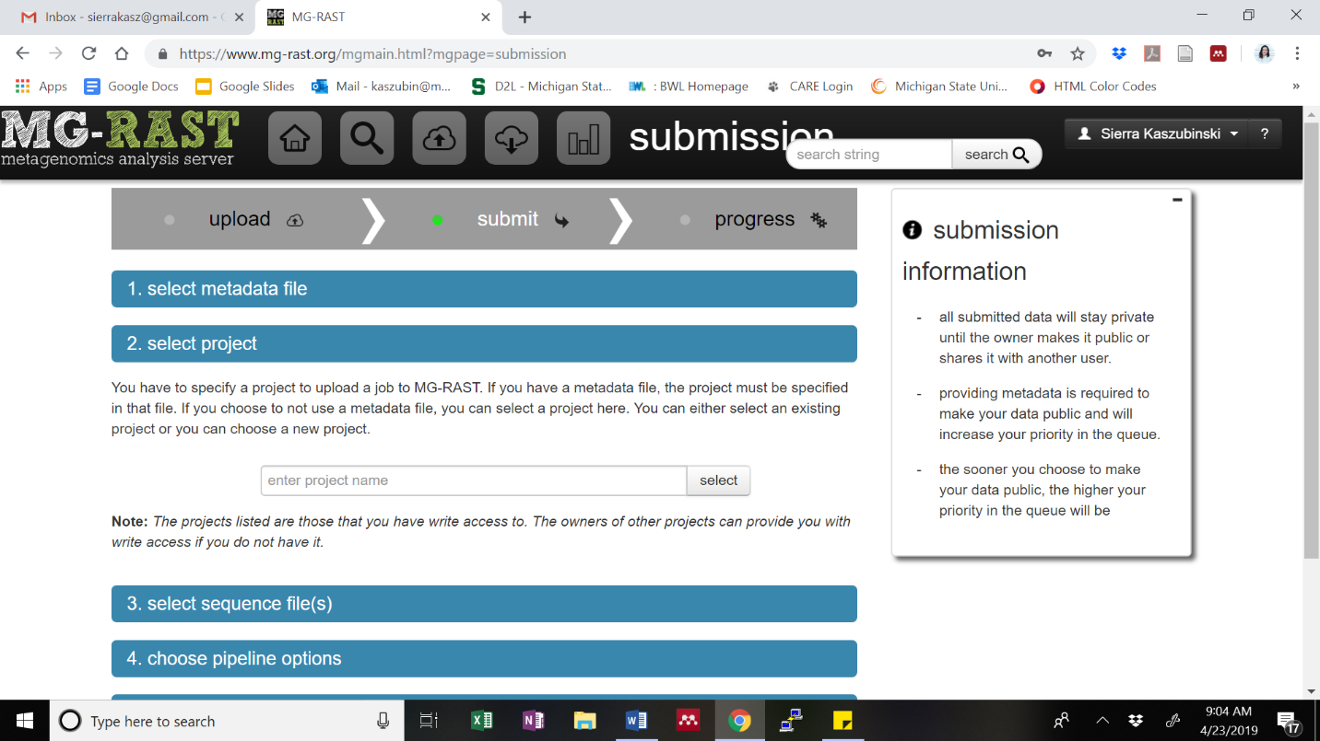

Select the sequence files, that were uploaded and processed in the inbox. If the file names are red, the file did not pass MG-RASTs’ checks and are not able to be submitted.

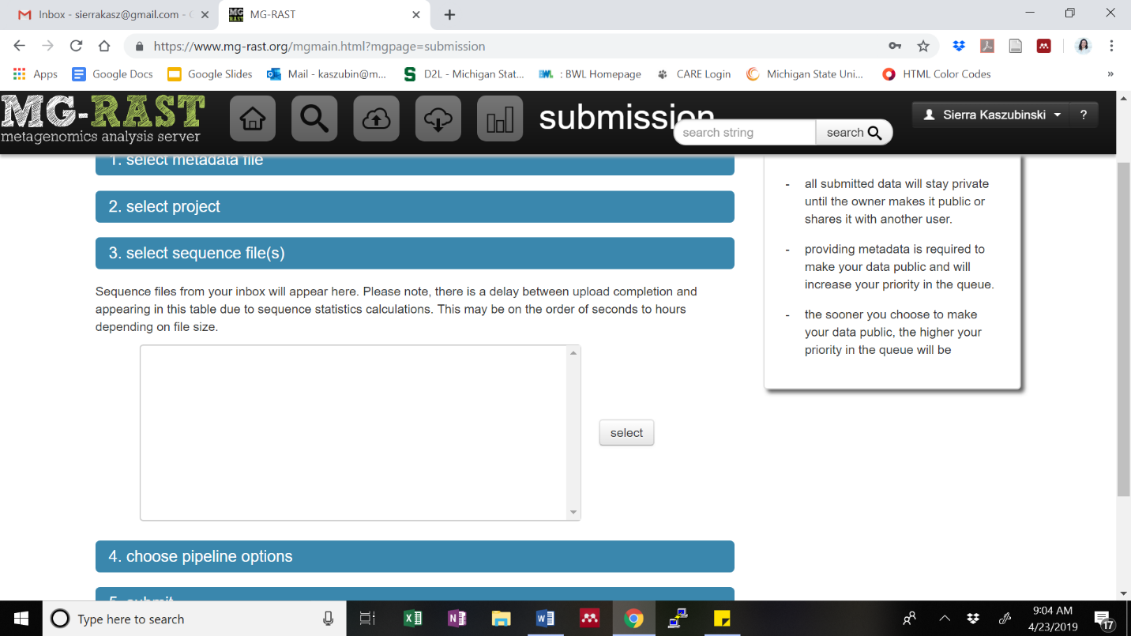

After selecting the files, you can choose pipeline options. The default parameters are already populated.

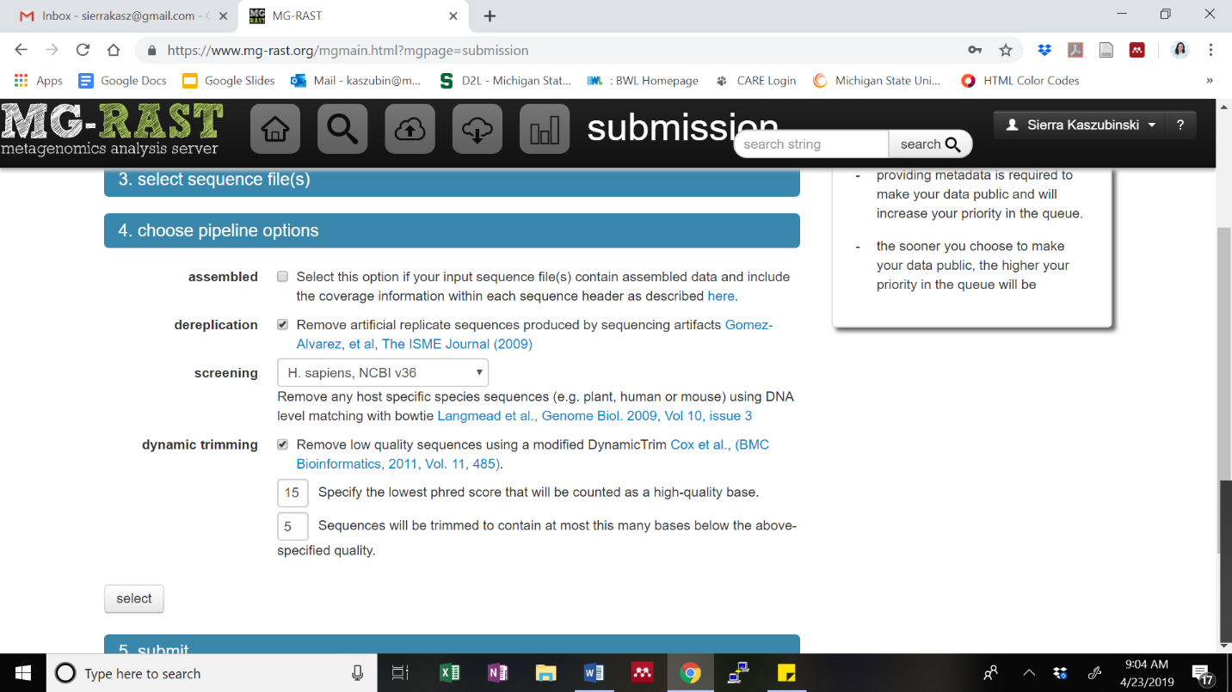

The last step is to select the data priority, which will change the data queue. After selected, you can submit the job.

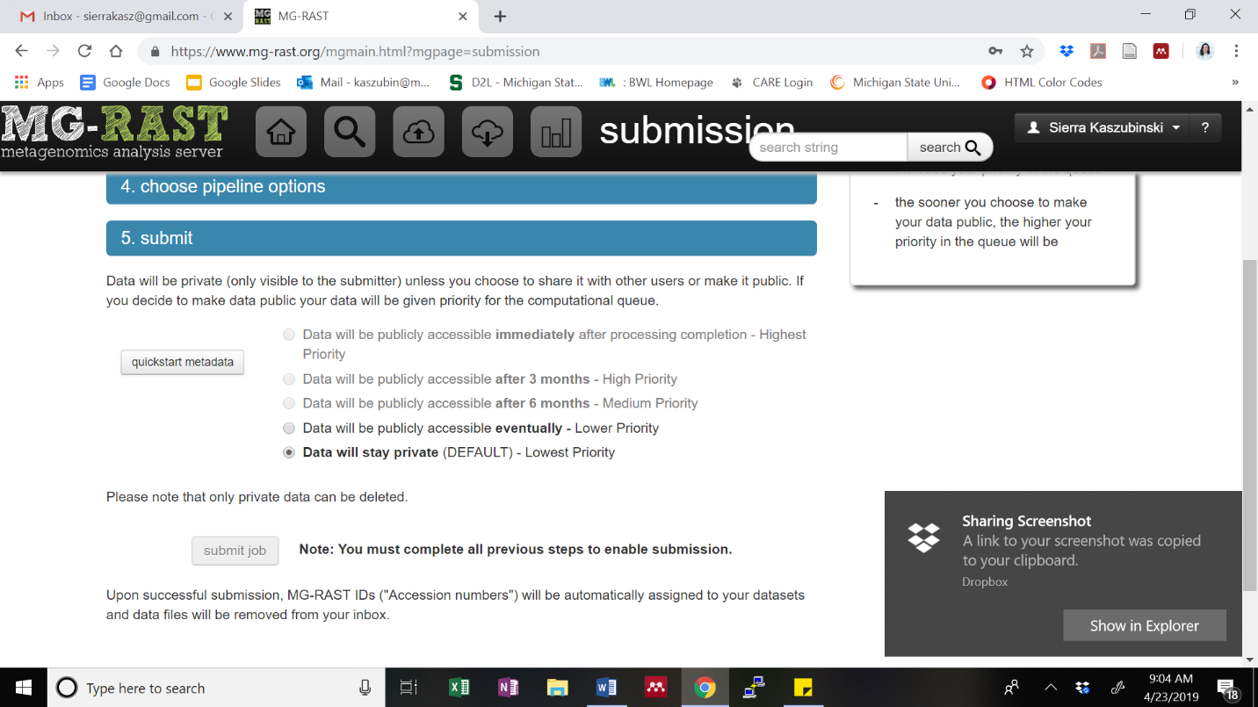

After submitting for pipeline analysis, you will receive emails when each file is completed. After all the files are completed, you can start the analysis portion.

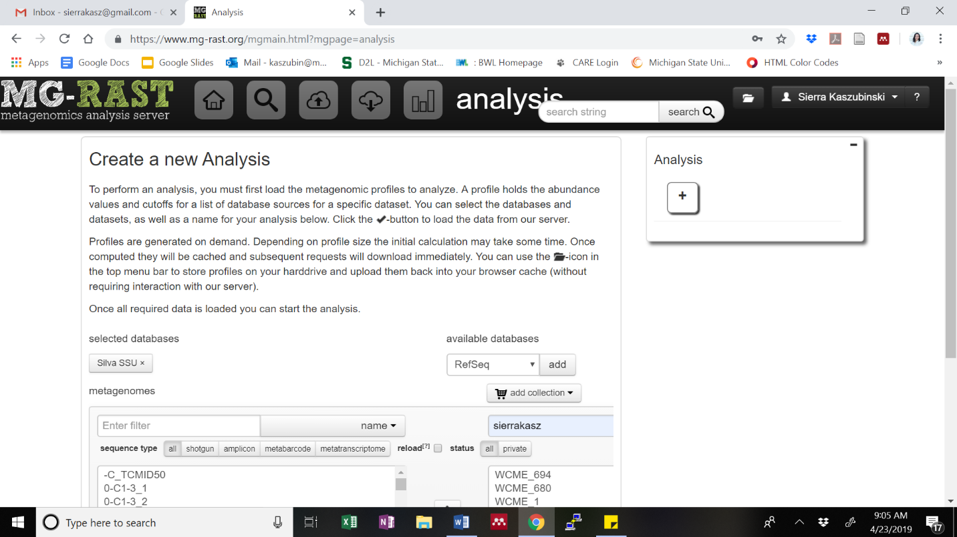

In the analysis window, you can select the reference database, and select the sequence files you want to include by adding a collection (project name).

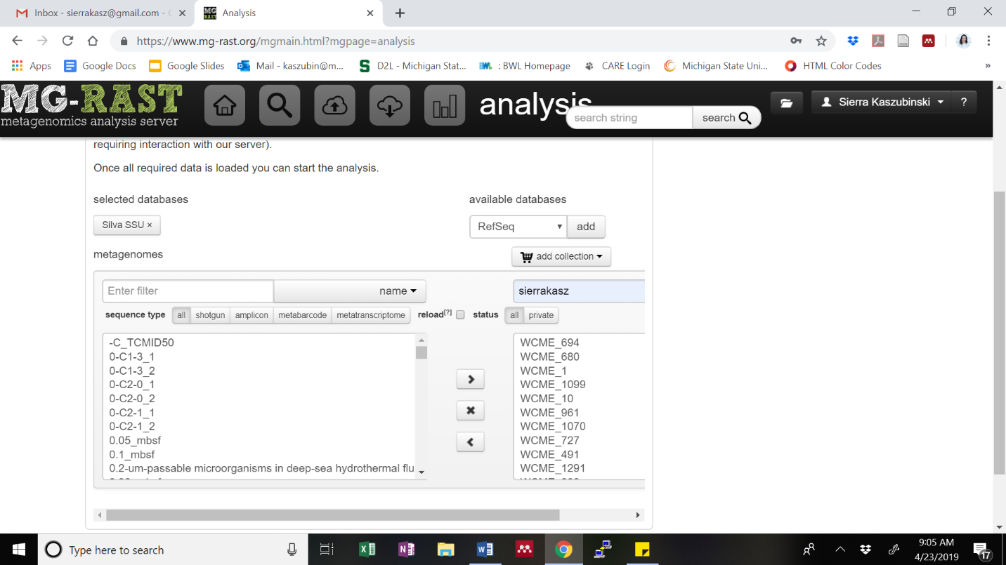

After selecting the database and sequences, click the check mark.

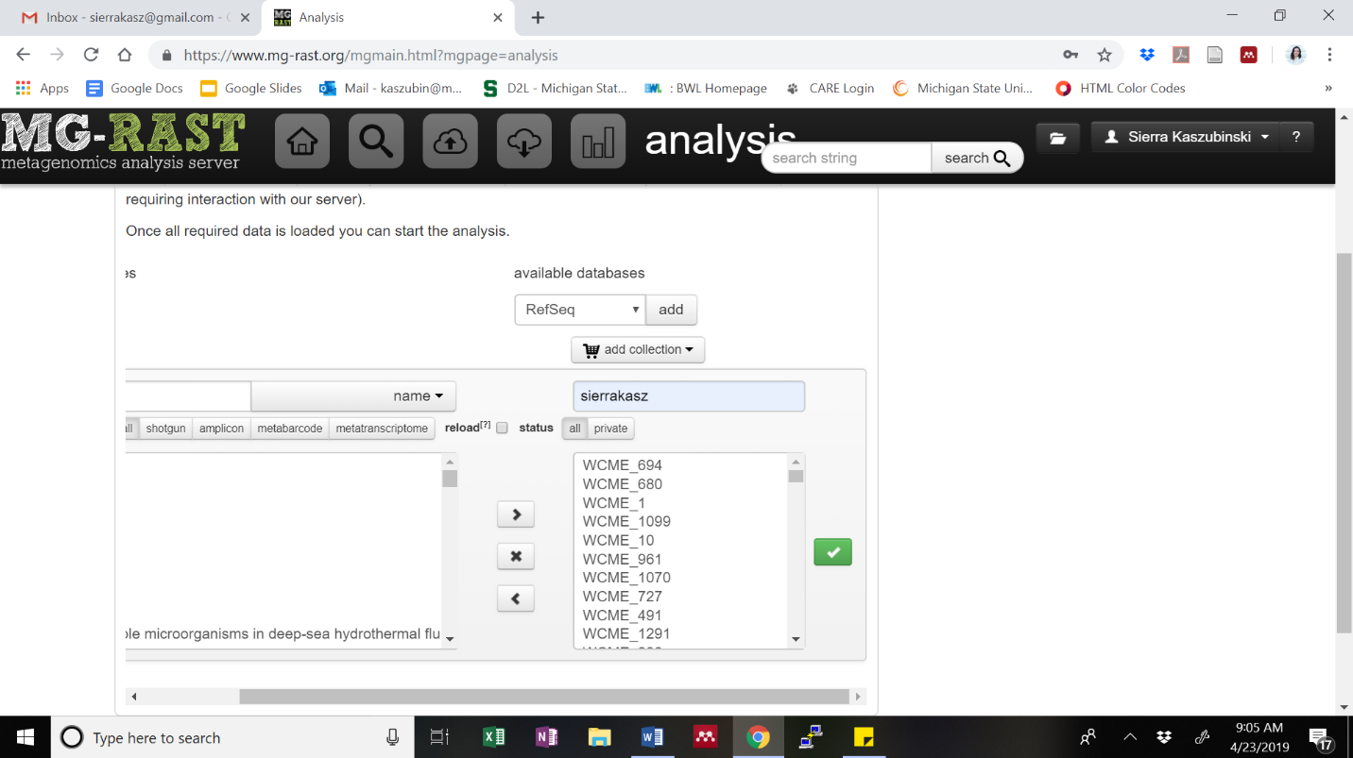

After uploading the files, you can run analysis. You can choose the following parameters, those populated are the from *Plummer et al.* Best hit should be selected.

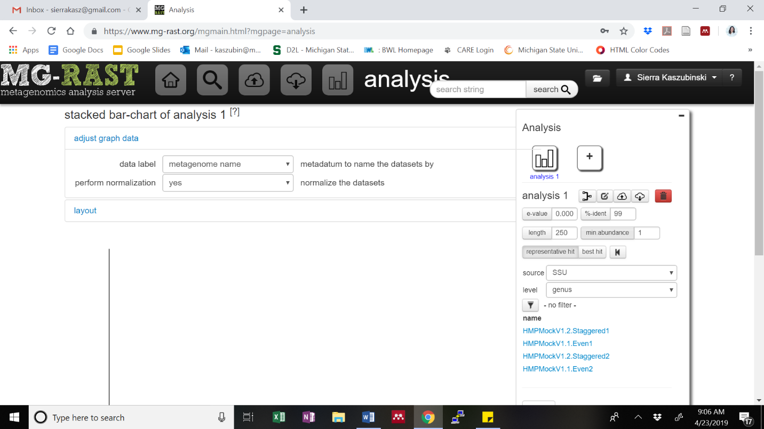

To export the data, click the TSV file option.

